**Vivekanand Education Society's Institute of Technology**



**Department of Computer Engineering**

**Group No.: 12**

**Date : 06-08-2024**

**Project Synopsis (2024-25) - Sem VII**

Development of a Digital Twin for Advanced Cardiovascular Disease (CVD) Monitoring and Management

Dr. Sharmila Sengupta

Associate Professor, Computer Engineering

Kinjala Ahuja Taufique Ansari Devangana Barua Dipanshu Ghime

V.E.S.I.T V.E.S.I.T V.E.S.I.T V.E.S.I.T

[2021.kinjala.ahuja@ves.ac.in](mailto:2021.kinjala.ahuja@ves.ac.in) [2021.taufique.ansari@ves.ac.in](mailto:2021.taufique.ansari@ves.ac.in) [2021.devangana.barua@ves.ac.in](mailto:2021.devangana.barua@ves.ac.in) [2021.dipanshu.ghime@ves.ac.in](mailto:2021.dipanshu.ghime@ves.ac.in)

# **Index**

| Sr. No | Title | Pg no. |
| --- | --- | --- |
| 1. | Abstract | 2 |
| 2. | Introduction | 3 |
| 3. | Problem Statement | 4 |
| 4. | Proposed Solution | 5 |
| 5. | Methodology / Block Diagram | 7 |
| 6. | Hardware , Software and tools Requirements | 10 |
| 7. | Proposed Evaluation Measures | 12 |
| 8. | Conclusion | 14 |
| 9. | References | 15 |

## 

# **Abstract**

Cardiovascular diseases (CVD) are a leading cause of mortality globally, necessitating innovative approaches for effective monitoring and management. This proposal introduces a groundbreaking project to develop a Digital Twin for CVD patients, integrating real-time physiological data, machine learning algorithms, and Generative AI (Gen AI) technologies. The Digital Twin will act as a dynamic, virtual replica of the patient’s cardiovascular system, providing continuous monitoring, predictive analytics, and personalized treatment simulations. By offering healthcare professionals and patients unprecedented insights into disease progression and treatment outcomes, this system aims to revolutionize CVD management, enhance patient care, and reduce healthcare costs. The project’s long-term vision is to set a new standard in personalized medicine, leveraging cutting-edge technology to improve patient outcomes and quality of life.

# **Introduction**

Cardiovascular diseases encompass a wide range of conditions, including coronary artery disease, heart failure, arrhythmias, and hypertension. These conditions pose significant challenges for healthcare systems worldwide due to their chronic nature and the necessity for continuous monitoring and complex management. Traditional healthcare models often rely on episodic care, which can result in delayed detection of complications and suboptimal treatment adjustments. With the rapid advancement of wearable technologies, electronic health records (EHRs), and artificial intelligence, there is a unique opportunity to enhance the management of CVD through continuous, personalized, and data-driven approaches.

A Digital Twin - a highly detailed virtual model of an individual’s cardiovascular system - can provide real-time insights into a patient’s health status. By continuously integrating data from various sources, including wearables, medical imaging, laboratory tests, and patient-reported outcomes, the Digital Twin can dynamically represent the patient's current and future health states. The incorporation of machine learning enables predictive analytics, while Gen AI can simulate various clinical scenarios, offering a comprehensive tool for clinicians and patients to explore potential treatment options and their outcomes. This proposal outlines the development of such a system, aiming to revolutionize the management of CVD by making it more proactive, personalized, and effective.

# **Problem Statement**

The current healthcare landscape faces several challenges in managing cardiovascular disease, primarily due to limitations in monitoring, diagnosis, and treatment personalization:

**Intermittent Monitoring:** The traditional model of care, characterized by periodic check-ups, often fails to capture the dynamic and fluctuating nature of cardiovascular conditions. Critical changes in a patient's health status may go unnoticed between visits, leading to delayed interventions and adverse outcomes.

**Lack of Personalized Care:** Standard treatment protocols typically do not account for the individual variability in disease progression, genetic predispositions, lifestyle factors, and responses to treatment. This one-size-fits-all approach can result in suboptimal outcomes and unnecessary side effects.

**Delayed Detection of Complications**: The inability to continuously monitor physiological parameters can delay the identification of emerging complications such as arrhythmias, heart attacks, and heart failure exacerbations. Early detection is crucial for timely intervention and improved prognosis.

**Inadequate Predictive Capabilities**: Existing systems lack robust tools for forecasting disease progression and potential health crises, limiting the ability to implement preventive measures and optimize treatment strategies.

**Communication Barriers:** The complexity of cardiovascular data and medical jargon can hinder effective communication between healthcare providers and patients, potentially impacting patient understanding, engagement, and adherence to treatment plans.

**High Healthcare Costs:** Inefficient management of CVD can lead to increased hospitalizations, emergency interventions, and overall healthcare expenditures. There is a critical need for more efficient and cost-effective care models.

# **Proposed Solution**

The proposed solution involves the development of an advanced Digital Twin platform specifically tailored for CVD patients. This platform will integrate various cutting-edge technologies to provide comprehensive, real-time monitoring and personalized care. The key components of the solution are as follows:

**Comprehensive Digital Twin Model:** A detailed virtual representation of the patient’s cardiovascular system, continuously updated with real-time data. This model will include anatomical and physiological characteristics, medical history, and current health status.

**Integrated Data Collection and Real-Time Monitoring:** The system will aggregate data from multiple sources, including wearable devices (e.g., smartwatches, fitness trackers, blood pressure monitors), medical imaging (e.g., echocardiograms, CT scans), laboratory results (e.g., lipid profiles, glucose levels), and patient-reported outcomes (e.g., symptoms, lifestyle habits). This holistic data integration will provide a comprehensive view of the patient’s health.

**Machine Learning-Powered Predictive Analytics:** The platform will employ advanced machine learning algorithms to analyze the collected data, identify patterns, and predict potential cardiovascular events. These predictive models will help in risk stratification, early detection of complications, and personalization of treatment plans.

**Generative AI for Scenario Simulation and Visualization:** Gen AI will be used to simulate various clinical scenarios, such as different treatment regimens, lifestyle interventions, and disease progression pathways. These simulations will provide valuable insights into potential outcomes, helping clinicians and patients make informed decisions.

**User-Friendly Visualization and Interface:** The platform will feature intuitive dashboards and graphical interfaces that display key metrics, trends, and predictive insights. These visualizations will be accessible to both healthcare providers and patients, facilitating clear communication and shared decision-making.

# **Block Diagram**

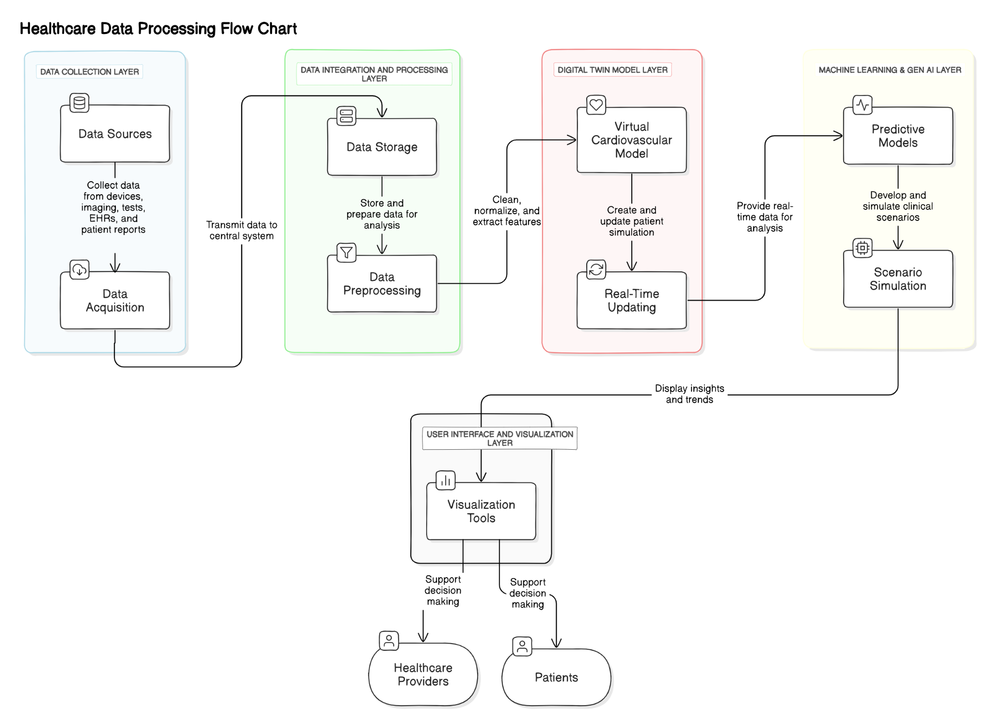

**Data Collection Layer:**

Data Sources: Data will be collected from wearable devices (e.g., heart rate monitors, blood pressure cuffs), medical imaging modalities (e.g., echocardiograms, MRI), laboratory tests, EHRs, and patient-reported outcomes.

Data Acquisition: Secure APIs and data ingestion pipelines will facilitate real-time data collection and transmission to the central system.

**Data Integration and Processing Layer:**

Data Storage: A scalable, secure database infrastructure (e.g., cloud-based storage solutions) will store diverse data types, ensuring efficient retrieval and analysis.

Data Preprocessing: Automated data cleaning, normalization, and feature extraction algorithms will prepare the data for analysis, ensuring consistency and quality.

**Digital Twin Model Layer:**

Virtual Cardiovascular Model: This component will create a dynamic, high-fidelity simulation of the patient's cardiovascular system. It will incorporate anatomical structures, physiological functions, and clinical parameters.

Real-Time Updating: The model will be continuously updated with new data, reflecting changes in the patient's health status and allowing for real-time monitoring.

**Machine Learning & Gen AI Layer:**

Predictive Models: Machine learning algorithms, including supervised and unsupervised learning techniques, will be developed to identify risk factors, predict adverse events, and optimize treatment plans. Models will be trained on large datasets to ensure accuracy and generalizability.

Scenario Simulation: Gen AI models, such as Generative Adversarial Networks (GANs) and transformers, will simulate various clinical scenarios, enabling exploration of potential treatment outcomes and disease progression.

**User Interface and Visualization Layer:**

Visualization Tools: The platform will provide interactive dashboards and graphical interfaces, displaying key metrics, trends, and predictive insights in an easily understandable format. These tools will support both healthcare providers and patients in making informed decisions.

# **Detailed Methodology**

**Data Collection and Integration:**

Develop secure APIs for real-time data acquisition from wearables, medical devices, and EHR systems. Implement data fusion techniques to integrate disparate data sources into a cohesive dataset.

Ensure data privacy and security through encryption, access control, and compliance with healthcare regulations.

**Digital Twin Development:**

Utilize computational modeling techniques to create a virtual representation of the cardiovascular system, incorporating patient-specific anatomical and physiological data.

Implement algorithms for real-time model updating based on incoming data, allowing for continuous monitoring and analysis.

**Machine Learning Analysis:**

Develop and train predictive models using historical and real-time patient data. Focus on key outcomes such as arrhythmias, myocardial infarctions, and heart failure exacerbations.

Employ feature selection and dimensionality reduction techniques to enhance model performance and interpretability.

**Generative AI Simulation:**

Use GANs and transformer models to simulate various clinical scenarios, such as the effects of medication changes, lifestyle modifications, and surgical interventions.

Validate simulation results through expert review and comparison with real-world outcomes.

**Visualization and User Interface:**

Design and implement user-friendly interfaces for displaying data, trends, and predictions. Focus on usability, clarity, and accessibility for both medical professionals and patients.

Incorporate interactive elements, such as scenario simulation controls and data exploration tools, to facilitate in-depth analysis and decision-making.

# 

# **Hardware, Software, and Tools Requirements**

**Hardware**

Wearable Devices: Devices capable of monitoring physiological parameters such as heart rate, blood pressure, oxygen saturation, and physical activity. Examples include smartwatches, fitness trackers, and specialized medical devices.

Server Infrastructure: High-performance servers or cloud-based infrastructure (e.g., AWS, Azure, Google Cloud) for data storage, processing, and model deployment. Requirements include robust computational power, storage capacity, and network bandwidth.

**Software**

Data Integration Platforms: Tools for real-time data streaming and integration, such as Apache Kafka, Apache NiFi, or custom APIs.

Machine Learning Frameworks: Libraries and platforms for developing and deploying machine learning models, including TensorFlow, PyTorch, Keras, and scikit-learn.

Generative AI Tools: Software for implementing GANs, transformers, and other generative models, such as TensorFlow GAN, OpenAI GPT, and Hugging Face Transformers.

Database Management Systems: SQL and NoSQL databases (e.g., MySQL, PostgreSQL, MongoDB) for structured and unstructured data storage and management.

Data Security Software: Solutions for encryption, access control, and compliance, including SSL/TLS, VPNs, and firewalls.

**Tools**

EHR Integration: Standards and protocols for seamless data exchange with electronic health records, including HL7, FHIR, and DICOM.

Visualization Software: Tools for creating interactive and informative dashboards, such as Tableau, Power BI, and D3.js.

Development and Deployment Tools: Version control systems (e.g., Git), containerization platforms (e.g., Docker), and continuous integration/continuous deployment (CI/CD) tools (e.g., Jenkins).

# 

# **Proposed Evaluation Measures**

To ensure the effectiveness and impact of the Digital Twin platform, a comprehensive evaluation framework will be established, focusing on the following key metrics:

**Accuracy of Predictive Models:**

Evaluate the predictive performance of machine learning models using metrics such as precision, recall, F1-score, and area under the receiver operating characteristic curve (AUC-ROC). These metrics will assess the models' ability to accurately predict cardiovascular events and complications.

**User Engagement and Satisfaction:**

Conduct surveys and interviews with healthcare providers and patients to gather qualitative and quantitative feedback on the platform's usability, effectiveness, and overall experience. Key indicators will include user satisfaction scores, ease of use, and perceived value.

**Clinical Outcomes:**

Measure the impact of the Digital Twin platform on clinical outcomes, including the incidence of adverse events, hospitalization rates, and overall patient health. Comparisons will be made between patients using the platform and those receiving standard care to assess the system's effectiveness in improving clinical outcomes.

**System Performance:**

Monitor the technical performance of the platform, including system uptime, latency, data processing speeds, and scalability. These metrics will ensure the system's reliability, responsiveness, and capacity to handle large volumes of data.

**Cost-Effectiveness:**

Analyze the economic impact of the Digital Twin platform by evaluating healthcare cost savings associated with reduced hospitalizations, optimized treatment plans, and preventive care. A cost-benefit analysis will be conducted to quantify the financial benefits of the system.

**Regulatory Compliance and Data Security:**

Ensure that the platform complies with relevant healthcare regulations, such as HIPAA and GDPR, and meets stringent data security standards. Regular audits and assessments will be conducted to verify compliance and data protection measures.

# 

# 

# 

# 

# 

# 

# 

# **Conclusion**

The development of a Digital Twin for cardiovascular disease management represents a paradigm shift in how CVD is monitored and treated. By integrating real-time data, machine learning, and Generative AI, the proposed platform offers a comprehensive, personalized, and proactive approach to healthcare. The Digital Twin will provide continuous monitoring, predictive analytics, and scenario simulation, enabling early detection of complications, personalized treatment planning, and improved patient outcomes.

This project aims to empower healthcare professionals with advanced tools and insights, facilitating better decision-making and patient engagement. It also seeks to enhance the patient experience by providing clear and accessible information about their health and treatment options. The successful implementation of this platform could lead to significant improvements in clinical outcomes, reduced healthcare costs, and a higher quality of life for CVD patients.

Moreover, the Digital Twin framework developed in this project has the potential to be adapted and applied to other chronic diseases, further extending its impact and benefits. By setting a new standard in personalized medicine, this project aspires to contribute to the broader transformation of healthcare into a more data-driven, patient-centered, and efficient system.

The proposed Digital Twin platform for CVD management is an ambitious and innovative initiative that seeks to harness the power of advanced technologies to improve patient care. With a focus on precision, personalization, and proactivity, this project represents a significant step forward in the fight against cardiovascular disease and the pursuit of better health outcomes for all.

**References :**

**The health digital twin to tackle cardiovascular disease—a review of an emerging interdisciplinary field**

(Genevieve Coorey,corresponding author1,2 Gemma A. Figtree,1,3 David F. Fletcher,4 Victoria J. Snelson,1,5 Stephen Thomas Vernon,3,6 David Winlaw,7 Stuart M. Grieve,1,5 Alistair McEwan,8 Jean Yee Hwa Yang,5 Pierre Qian,1,9 Kieran O’Brien,10 Jessica Orchard,5 Jinman Kim,11 Sanjay Patel,1,12,13 and Julie Redfern1)

<https://www.ncbi.nlm.nih.gov/pmc/articles/PMC9418270/>

**Digital twins for health: a scoping review**

(Evangelia Katsoulakis, Qi Wang, Huanmei Wu, Leili Shahriyari, Richard Fletcher, Jinwei Liu, Luke Achenie, Hongfang Liu, Pamela Jackson, Ying Xiao, Tanveer Syeda-Mahmood, Richard Tuli & Jun Deng)

<https://www.nature.com/articles/s41746-024-01073-0>